# **Why Look at Case Studies ??**

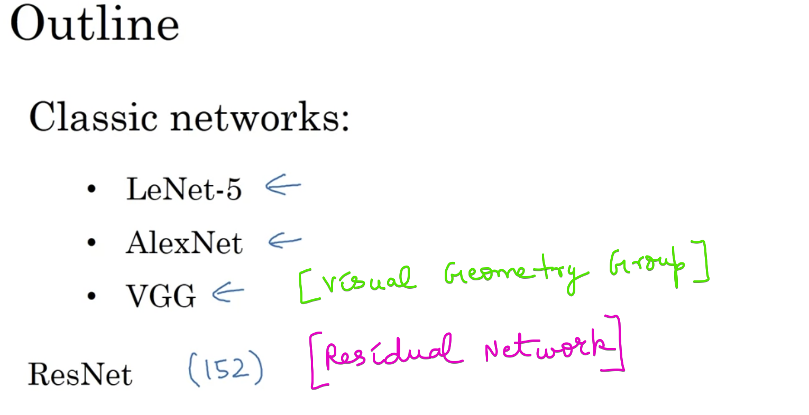

# **Classical Networks**

Stride 🡪 Six 5*5 filter

Average Pool 🡪 filter=2; stride=2

Sub-Sampling also known as Pooling

The above network recognizes digits from 0 to 9. So the size of the output is 10

